# Chapter 5: Testing

## Testing

Software testing is define as an action to verify the result with the actual expected result ensuring the program is problem free. It includes finalizing of system components to illustrate the properties given by the client.

It differentiates errors, problems and missing function. Testing is executed physically and systematically more importantly. Many of the programmer intend to test in white box and black box.

In this program, we have tested in white box and black box.

**Unit testing (White Box testing)**

Unit testing is a type of software testing where all the components of the project are tested. (Anon, 2018) It is performed so that there would not be any technical errors in the near future till the site is upgraded. A unit is the smallest amount of a substance, as the project consist of many unit function each an every method should be tested before handing over to the client. Unit testing is very necessary as each an every method is important to form a complete project and no functional errors are occurred.

|  |  |  |  |
| --- | --- | --- | --- |
| **Case Name** | **Data Passed** | **Expected** | **Result** |
|  |  |  |  |

|  |  |  |  |
| --- | --- | --- | --- |
| **Case Name** | **Data Passed** | **Expected** | **Result** |
|  |  |  |  |

|  |  |  |  |
| --- | --- | --- | --- |
| **Case Name** | **Data Passed** | **Expected** | **Result** |
|  |  |  |  |

|  |  |  |  |
| --- | --- | --- | --- |
| **Case Name** | **Data Passed** | **Expected** | **Result** |
|  |  |  |  |

|  |  |  |  |
| --- | --- | --- | --- |
| **Case Name** | **Data Passed** | **Expected** | **Result** |
|  |  |  |  |

|  |  |  |  |
| --- | --- | --- | --- |
| **Case Name** | **Data Passed** | **Expected** | **Result** |
|  |  |  |  |

**Black Box testing**

The testing technique where functionality of an application is checked by a normal user who does not have any knowledge about coding system of the project is called black box testing. It is tested with no internal code structure or implementation details. It is based on requirement and specification of the application. (Anon, 2018)

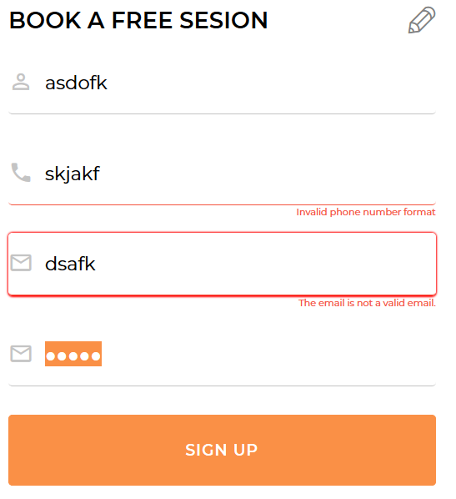

Figure 20: validation



Figure 21: user not logged in dashboard

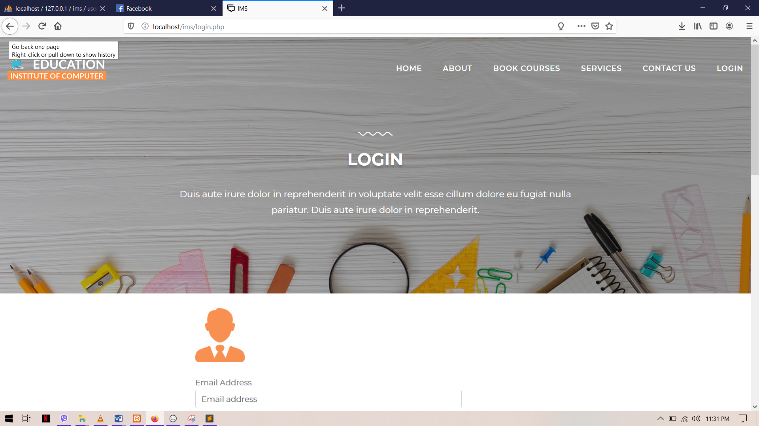

Figure 22: not signed in user



Figure 23: valid details

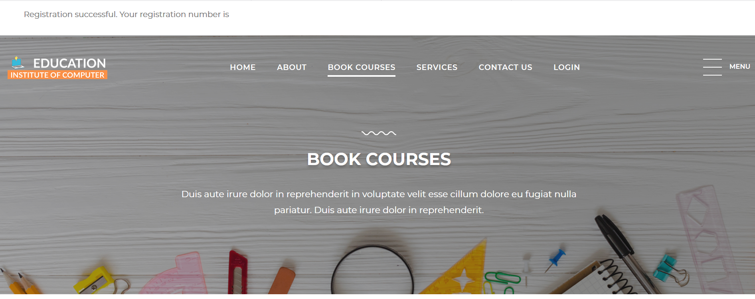

Figure 24: successfully registered

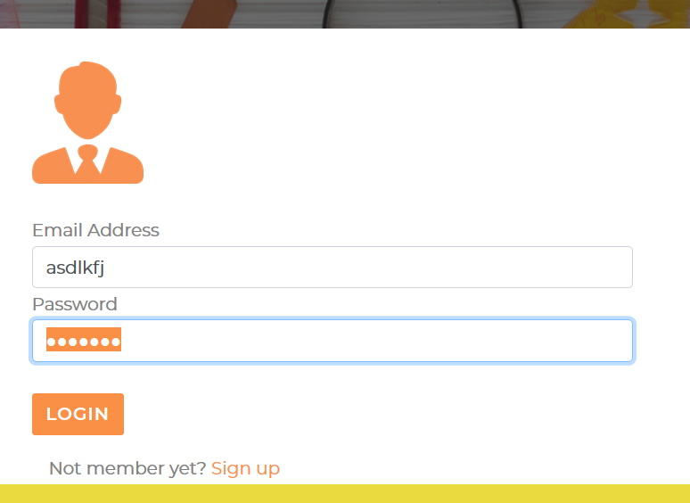

Figure 25: login validation

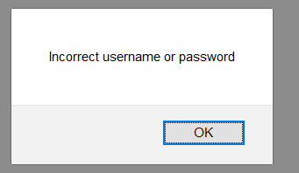

Figure 26: login validation

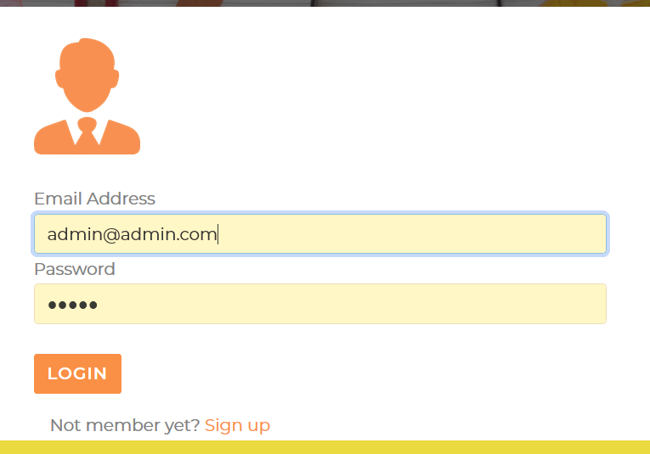

Figure 27: valid email and password

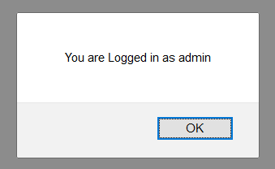

Figure 28: signed in



Figure 29: admin dashboard

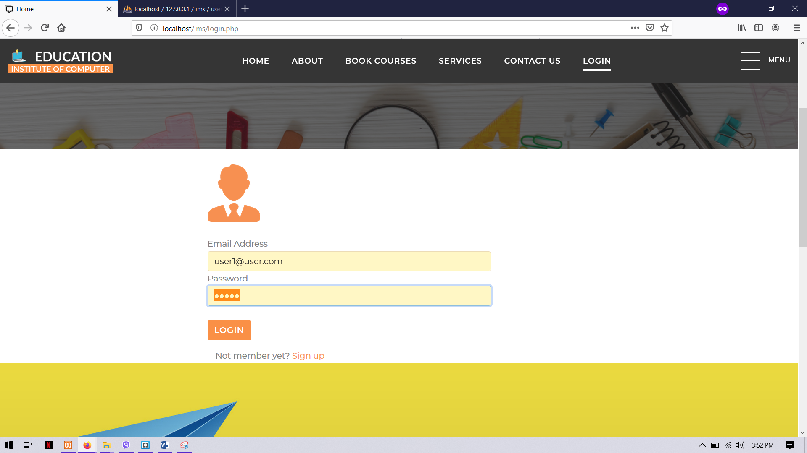

Figure 30: user login

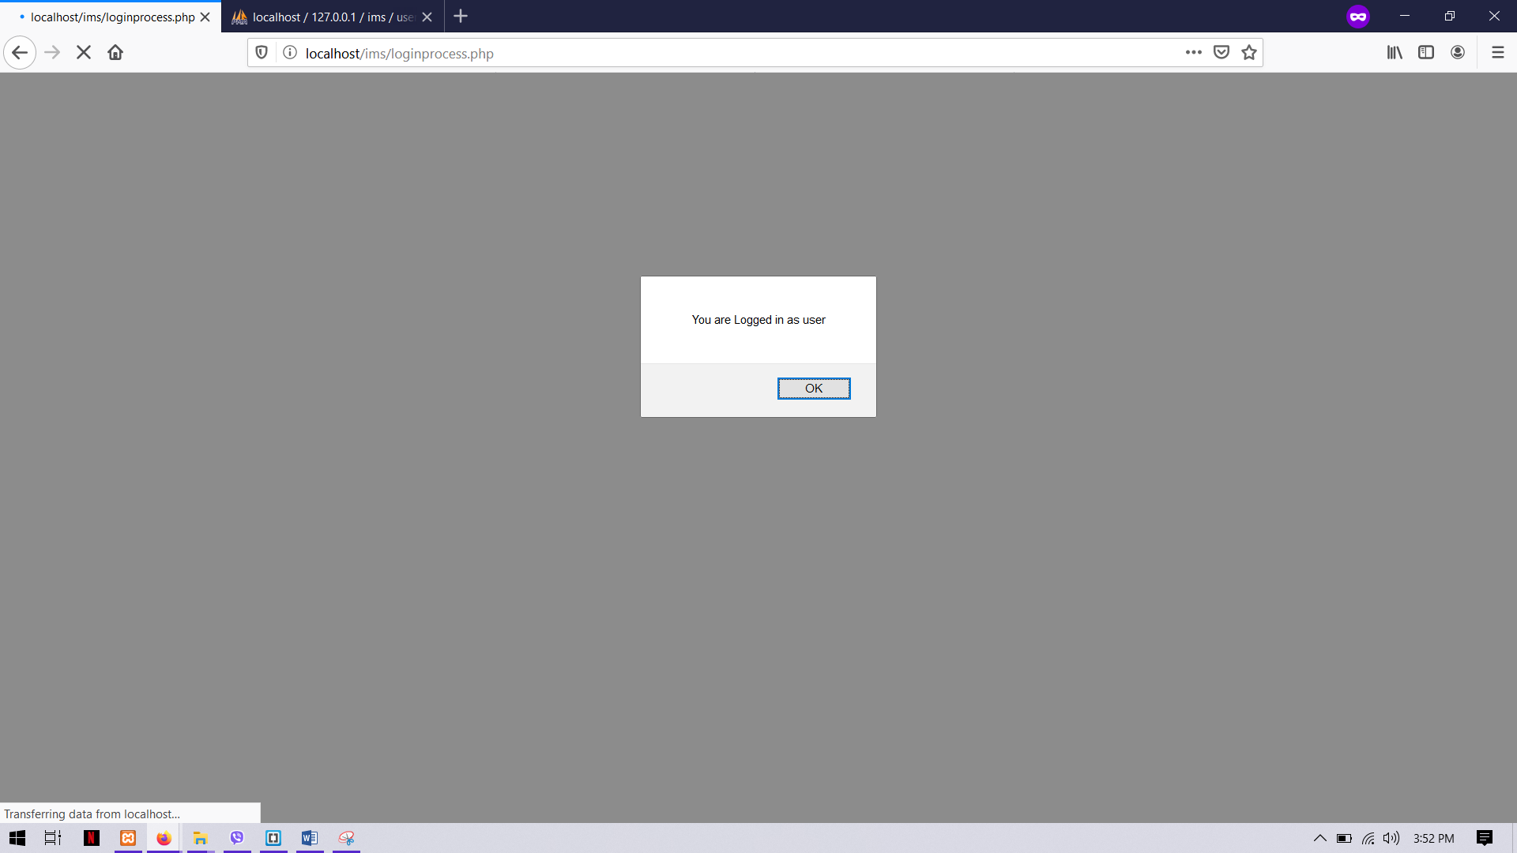

Figure 31: logged in as user

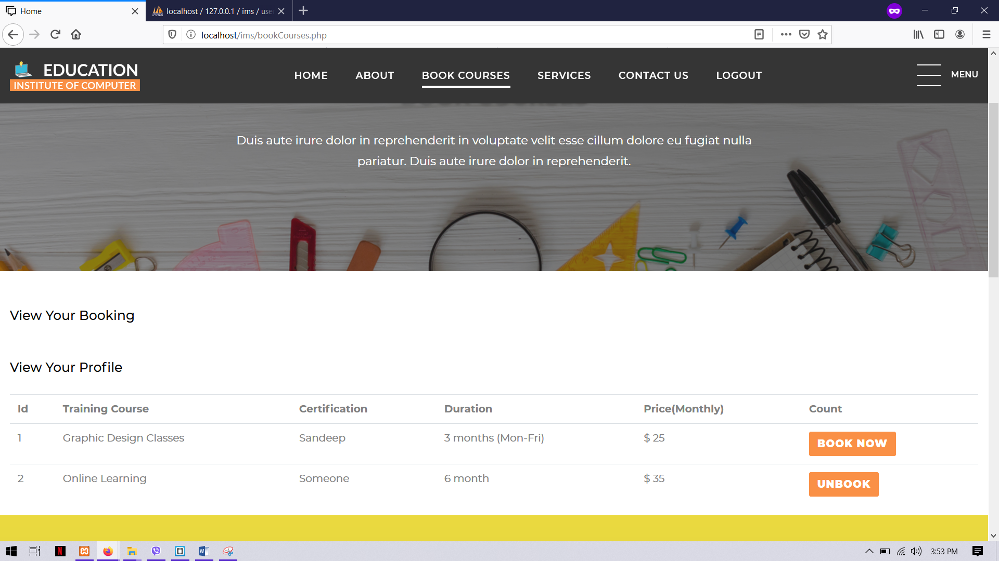

Figure 32: user dashboard

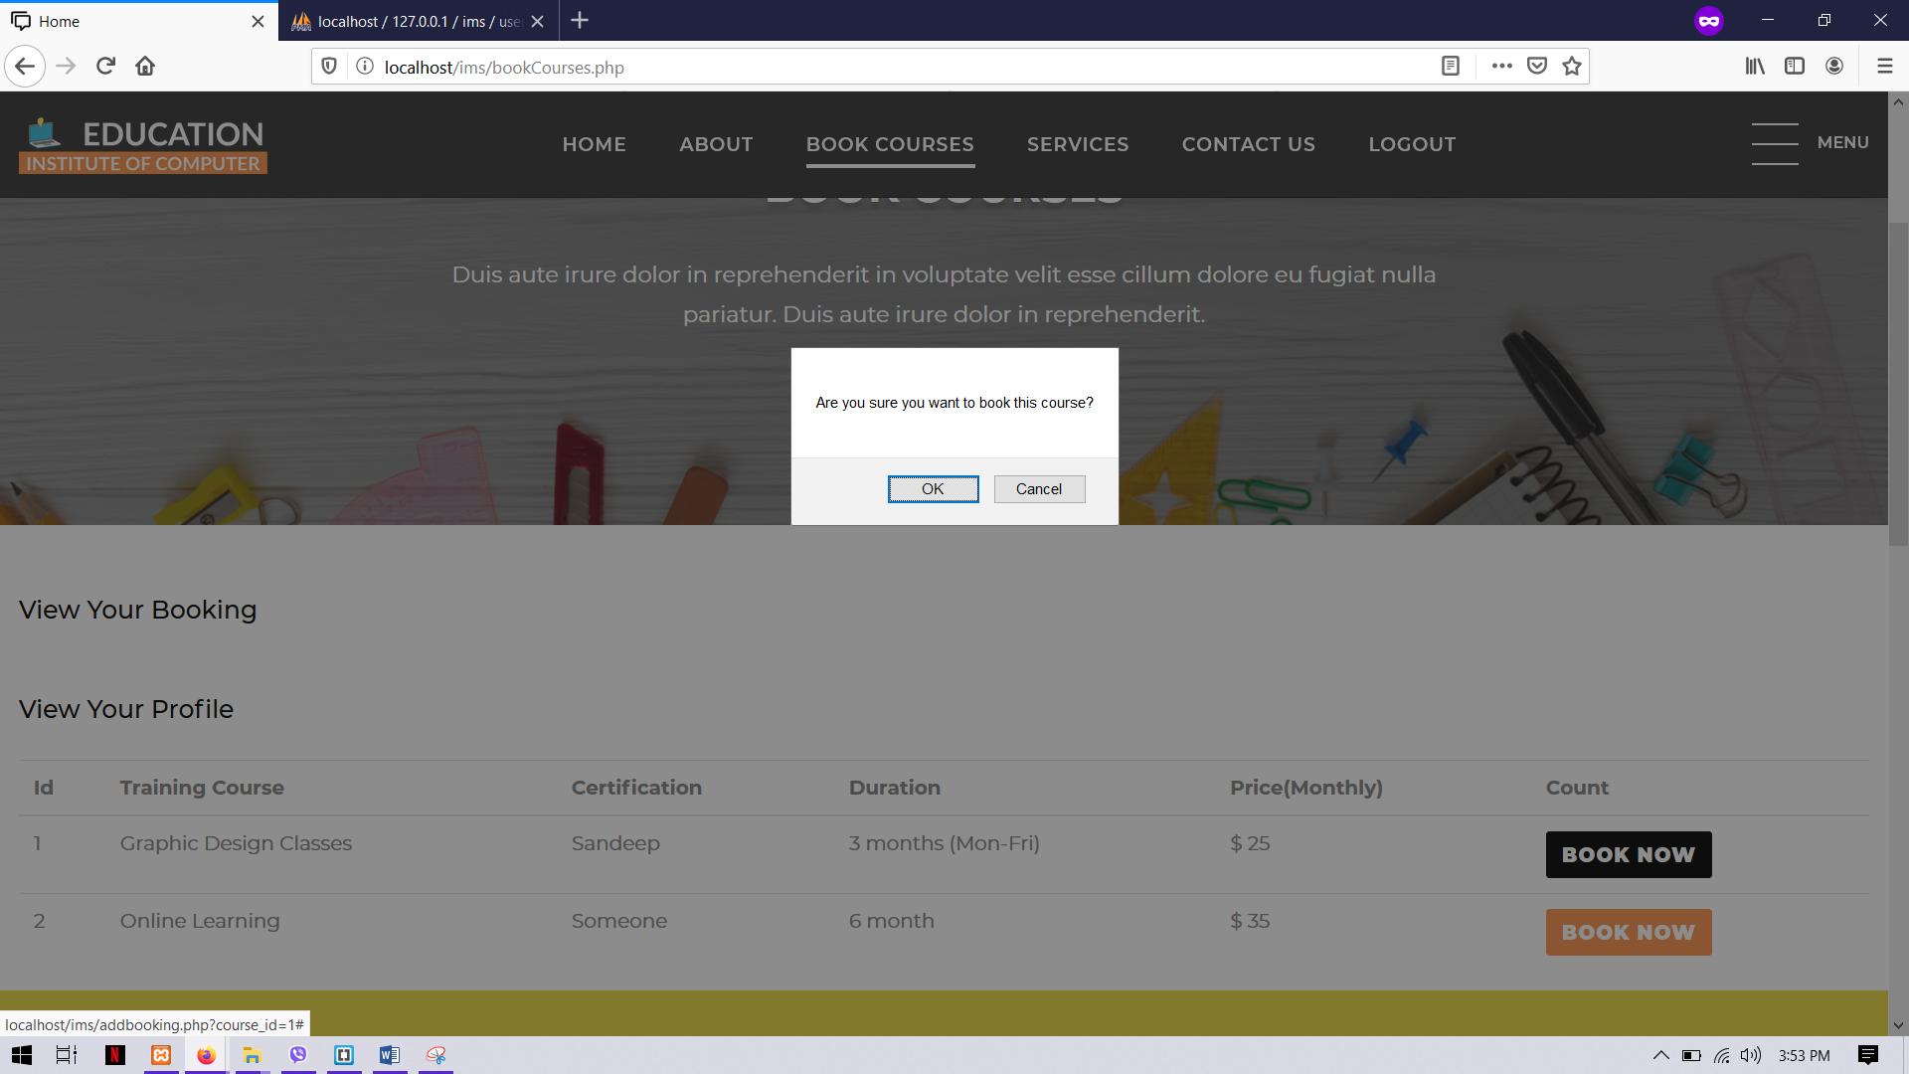

Figure 33: book course



Figure 34: booking successful



Figure 35: unbook course

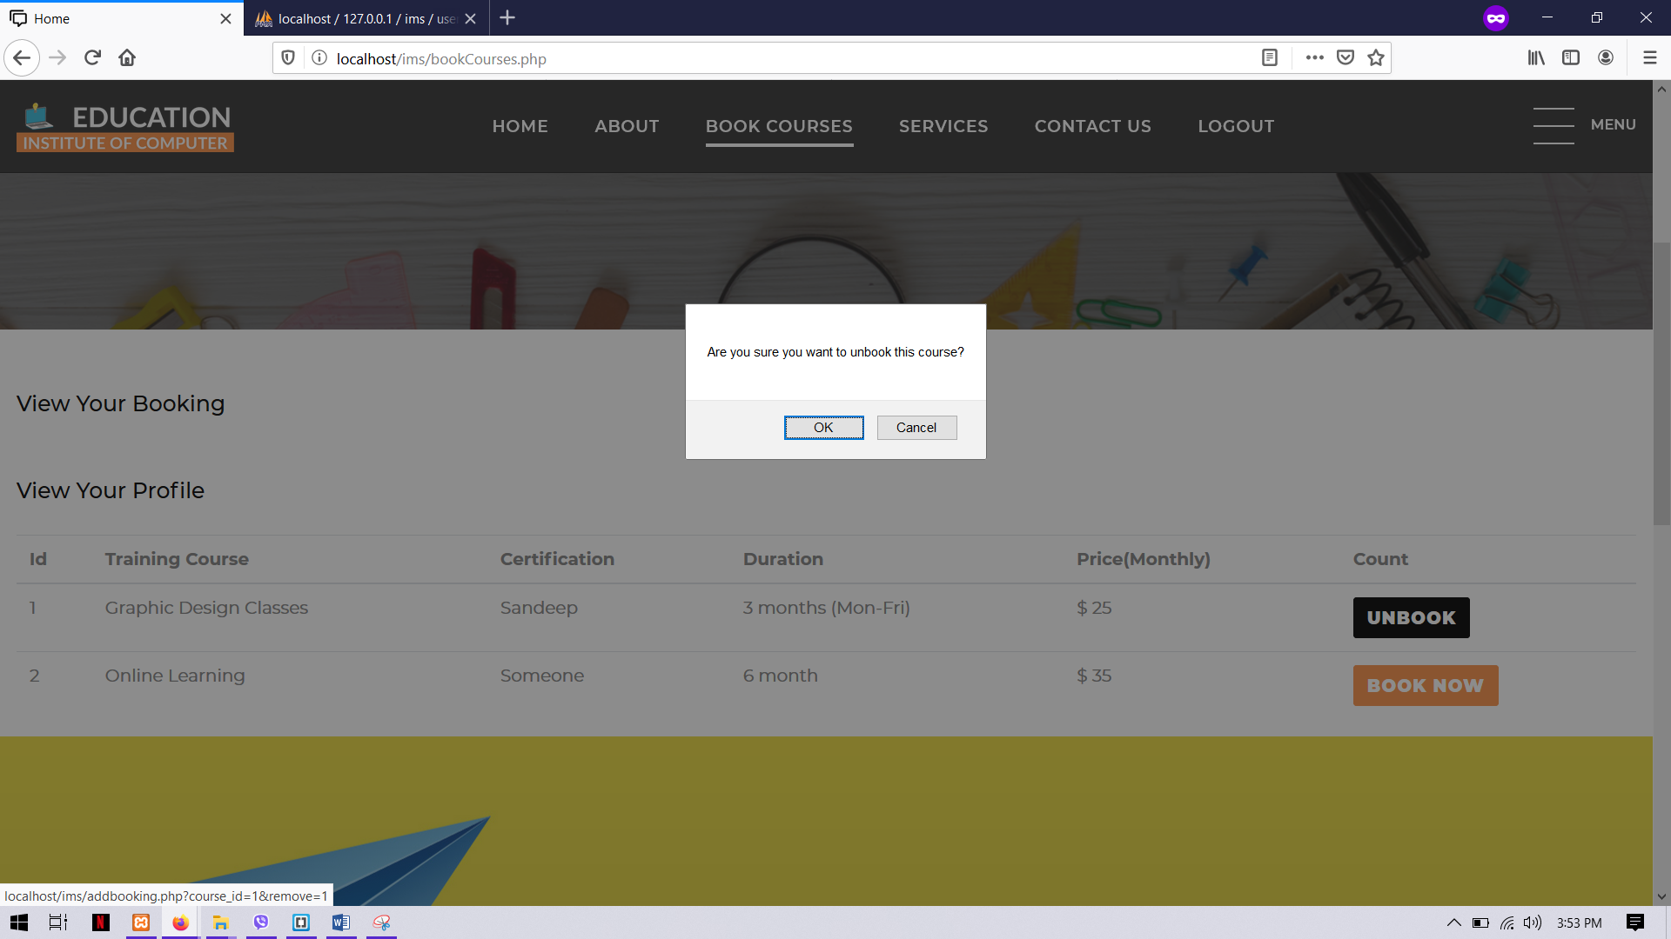

Figure 36: course UN booked



Figure 37: cancel booking successful

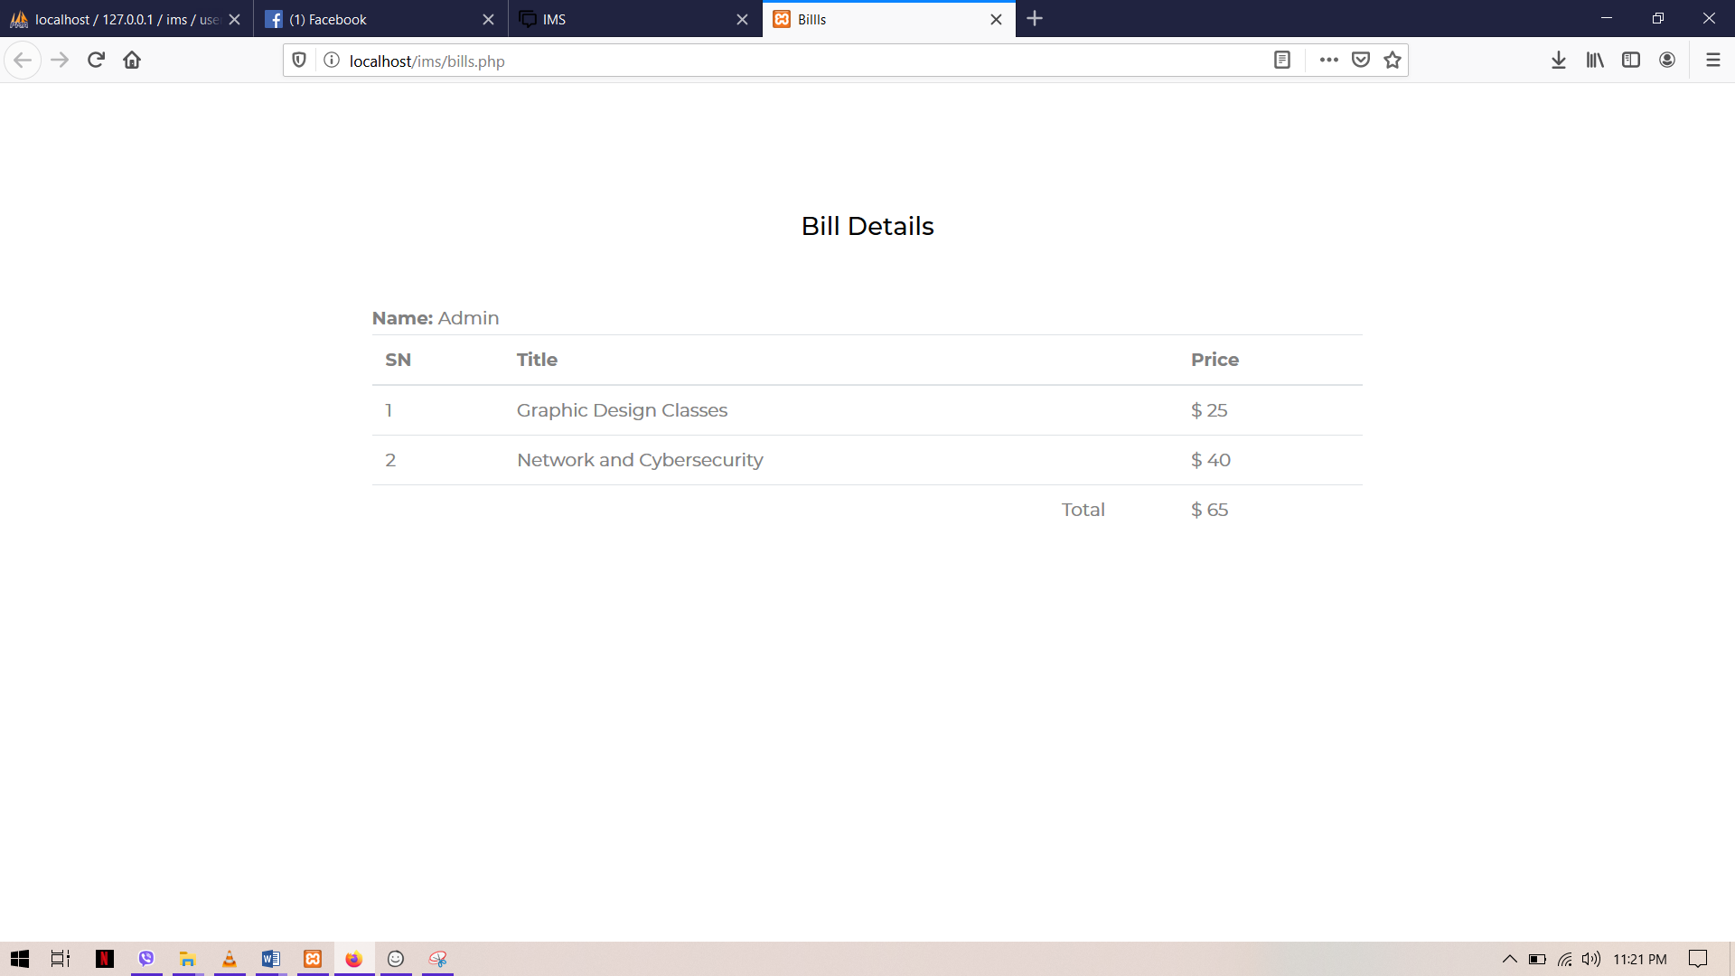

Figure 38: generate bill

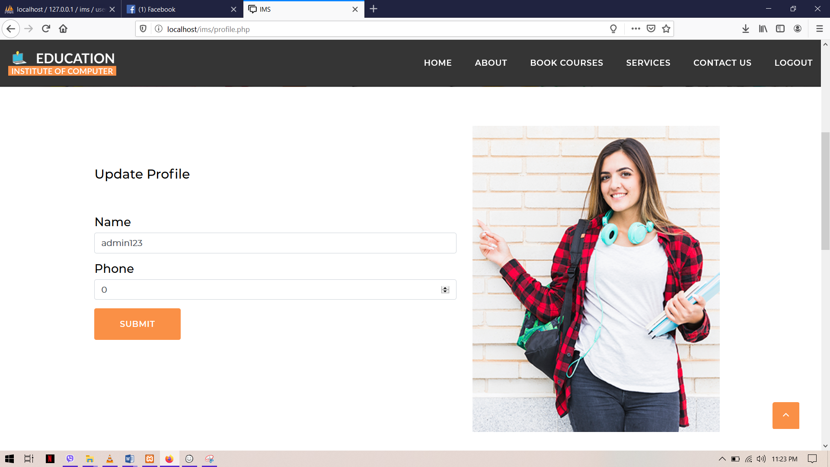

Figure 39: update profile



Figure 40: update profile successful

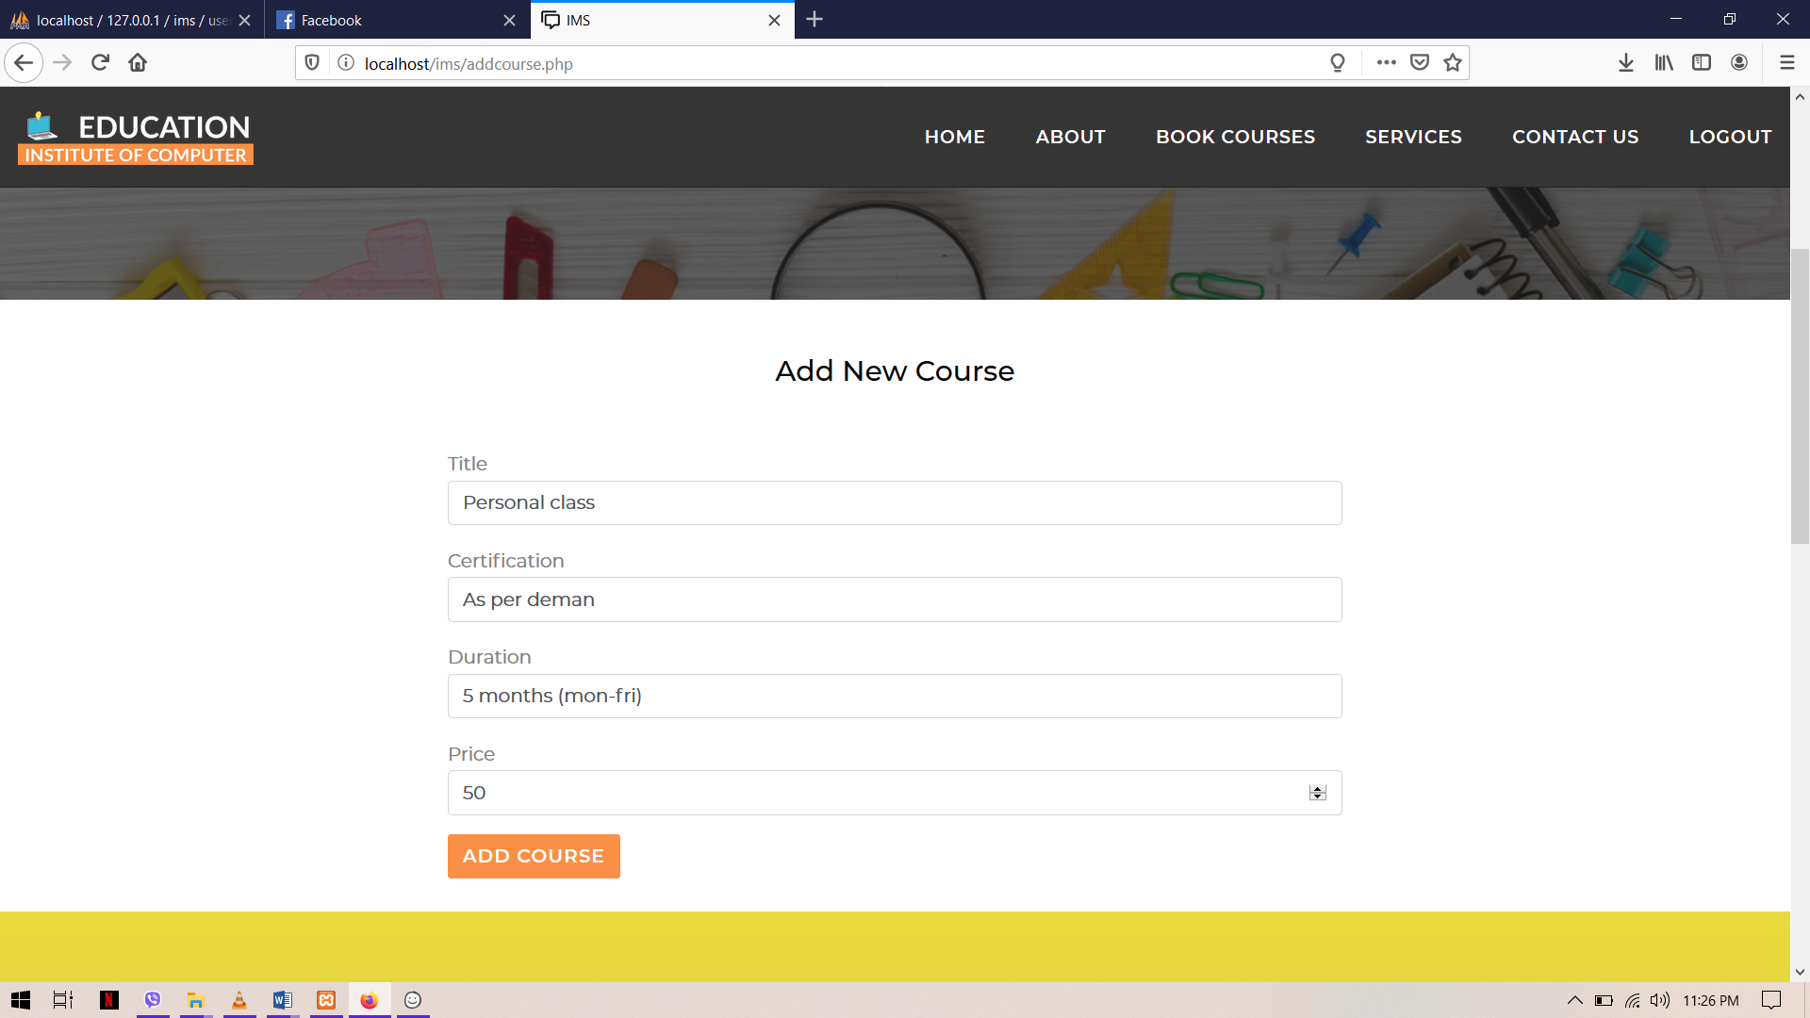

Figure 41: add courses



Figure 42: course added

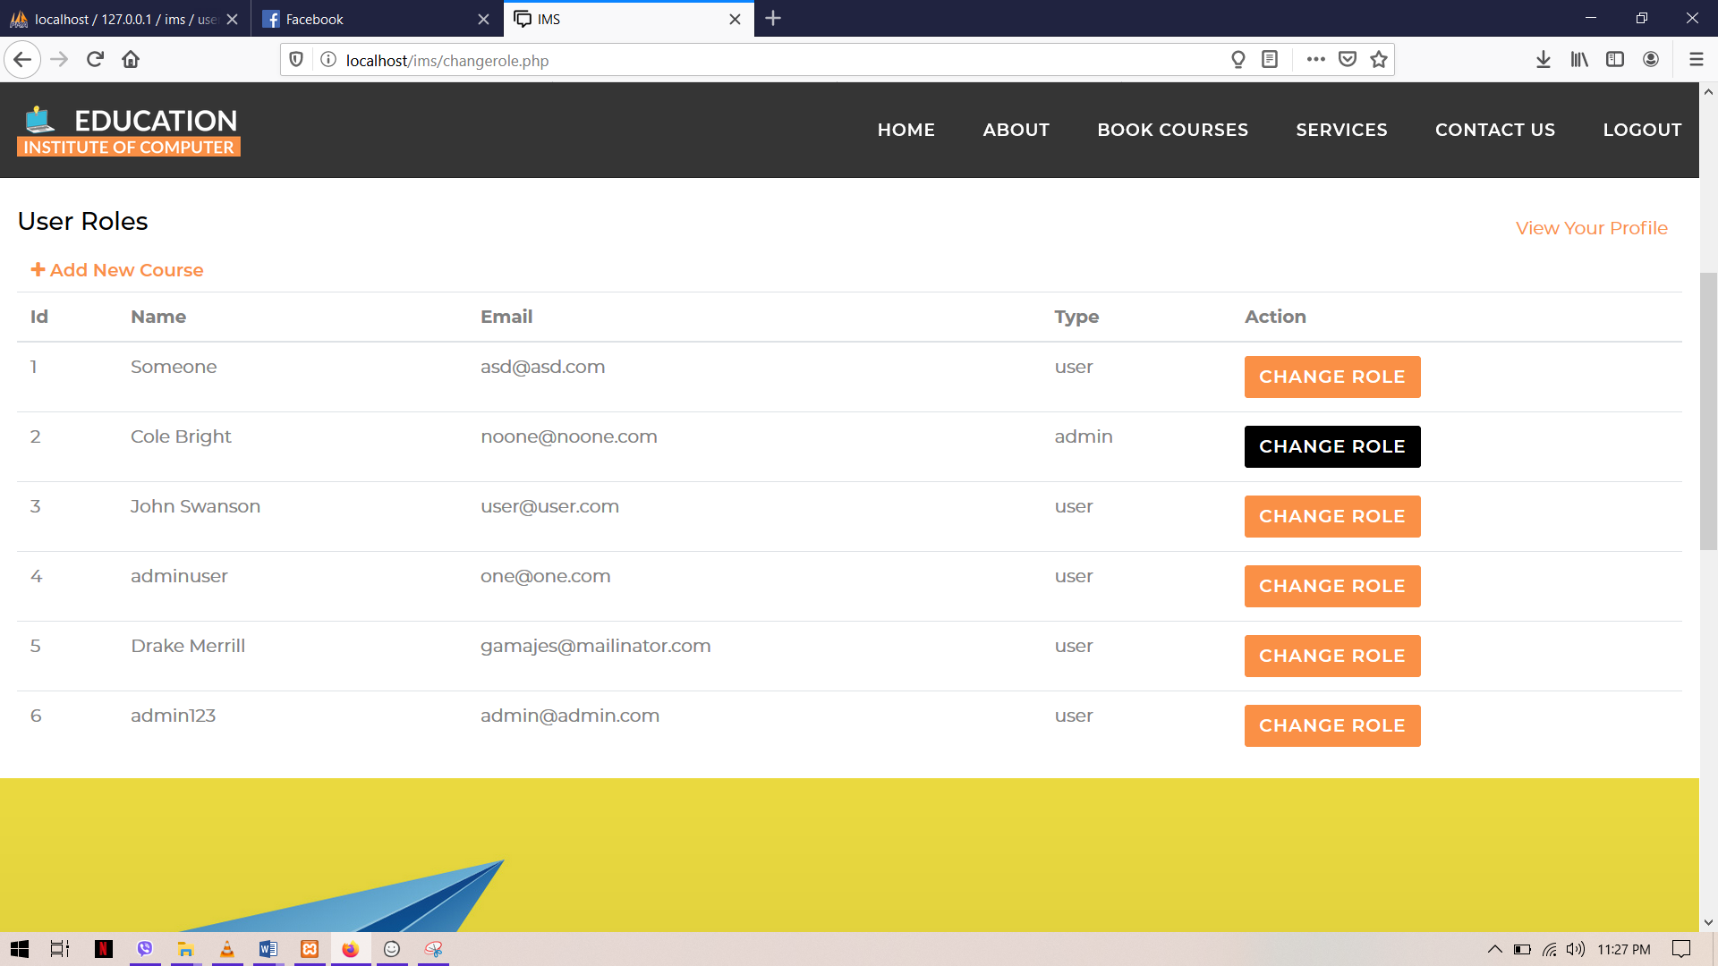

Figure 43: change user type



Figure 44: user Type changed

**Identification of Risk**

Risk management is the operation of controlling, identifying and evaluating risks to the application or program. These risks can damage the organization’s data, information, prestige, etc. Nowadays, people are more concerned about their personal data and billing details. Those risk impact on management, financial status and legal liabilities of the organization directly or indirectly. Risk management is usually evaluated in three areas like risk consequences, probability and affect due to risk.

**Risk management table**

This table evaluates the risk that may damage the program in the future days. This is to maintain the application for longer period of time with no attacks. Organization may lose their prestige, integrity, and etc. due to lack of maintenance.

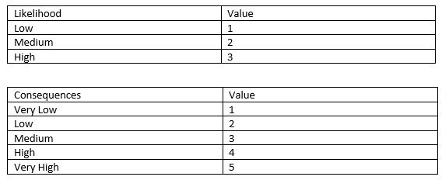

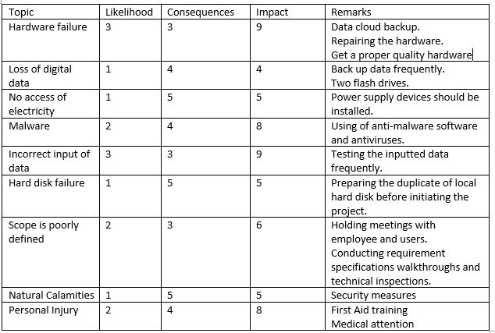

**Other issues**

Other issues are all the other unimplemented issues that may occur to the project due to lack of time, resources and technology. Different problems may occur even if it is not expected in the technical world.

**Future Works**

Many of the functions was not been able to add to the project due to lack of time and resources. Some of the features that may be added in the near future are as follows.

* Internet payment, E-banking could be implemented via various third party like PayPal in the coming days for simplicity of payment to the users.
* Various kind of time details of same course can be included.
* Search function by categorizing the classes was complicated may be useful while updating the system.

**Configuration Management**

It is a method for maintaining execution, cost, physical quality and plan similarly reliability in data for the life duration of the project. It also help to maintain complexity of the system.

File management of the project is effectively followed. For no threat to occur in any situation the file are manage in corporate order. It contains all the suitable document related with the organization of the system.

**User training**

User training is necessary to people who aren’t familiar to website an online booking. All the necessary interface are user friendly and easy to use. All the system of website are very simple made for student over 16 years so would not be a problem to book a course. If any of the user faces any difficulty they can concern to the institute itself and can help the needy. Like normal website, user can easily find booking if they are logged in. Even for the not user they can easily access register page and book a course.

**Limitation**

Institute management system consist of some limitation which includes online payment, various time schedule of courses, etc.

# Conclusion

The project was designed to perform an easy and simple booking system where students could book from home and no time was wasted visiting the institute. The project is more concerned to the user to find the best appropriate computer classes online. The system is easy simple as the new user have to register with giving small information about the user, to login it in next time user have to validate the id and password given before to book a course of class. As a standard website no hesitation will occur while accessing the site. To provide the user a good and easy site is the main ambition of the project.